Hands-on 4: Difference between JPA, Hibernate and Spring Data JPA
Objective: Understand the relationship and differences between JPA, Hibernate and Spring Data JPA.

Comparison
JPA | Hibernate | Spring Data JPA
Specification (Jakarta Persistence API). | ORM framework implementing JPA. | Spring module built on top of JPA.
Defines annotations like @Entity, @Id, @Table. | Maps Java objects to database tables. | Reduces boilerplate using JpaRepository.
No implementation. | Provides implementation. | Uses Hibernate (or another JPA provider) underneath.
Standard API. | Executes SQL and manages persistence. | Automatic CRUD, query methods and transaction integration.

Demonstration Using orm-learn Project
- Country.java demonstrates JPA annotations (@Entity, @Table, @Id, @Column).
- CountryRepository.java extends JpaRepository to provide CRUD operations.
- CountryService.java uses @Transactional and calls countryRepository.findAll().
- Application logs show Hibernate generating SQL automatically.

Code Snippets

1. Country Entity (JPA)
@Entity
@Table(name="country")
public class Country {
@Id
@Column(name="code")
private String code;
@Column(name="name")
private String name;
}

2. Repository (Spring Data JPA)
@Repository
public interface CountryRepository extends JpaRepository<Country, String> {
}

3. Service Layer
@Transactional
public List<Country> getAllCountries() {
return countryRepository.findAll();
}

4. Hibernate Generated SQL
select c1_0.code, c1_0.name from country c1_0;
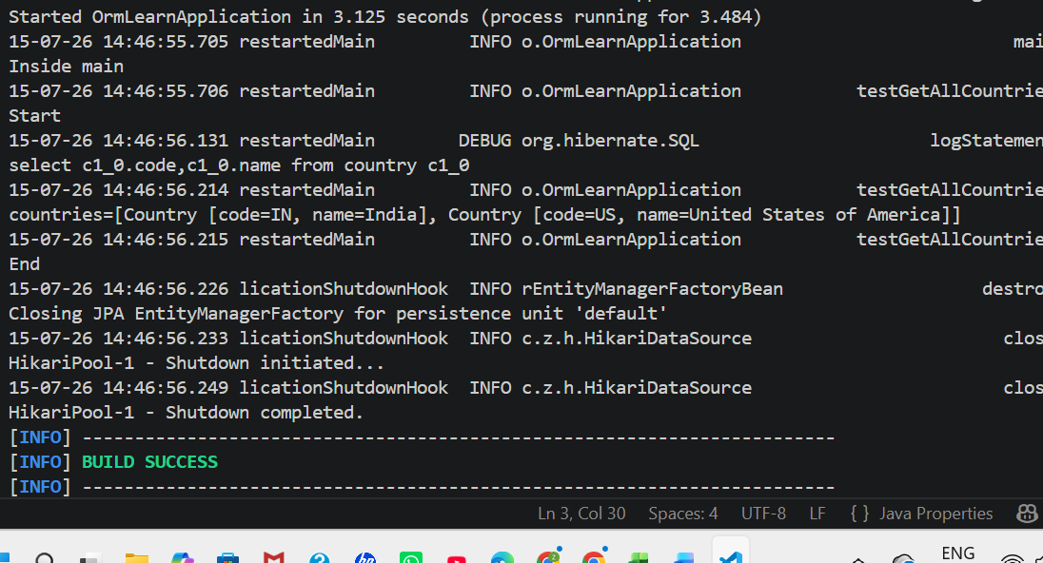

Conclusion
JPA defines the persistence standard, Hibernate implements that standard, and Spring Data JPA simplifies database access by providing repository interfaces and reducing boilerplate code.

